Appendix

Consultation(s):

Name of client : Profe Megan Dunn (my Spanish teacher)

Name of advisor : K Laxmi Priya (my mother)

Initial consultation with client and/or adviser First meeting:

I explained my project in detail to my client. My client gave her feedback and we decided on a flashcard app as many students lost their flashcards. The initial idea was a small game in between each question, but it was quickly scrapped as it would be too distracting for the students.

Second meeting:

As I was going through various ideas for my game as I didn’t want it to be a simple quiz game, I decided that a memory card game would be fun. I also read up on how they help students remember information faster and soon I was taken by the idea. I discussed this with my client and her approval and discussed whether my app should be web-based application or a phone app. At first, I thought it should be web based, but I soon changed my mind.

Third meeting:

My wireframes, class diagrams and flowcharts were all completed. I spoke to my client about them and explained how the app would work. She reviewed them and gave feedback. Other than the technical stuff she reminded me that the app would be for kids. This really stuck with me as I changed the look and feel of the app and made it more fun.

Fourth meeting:

I showed my client the view of the app and the working login and registration page. I also showed my client the working memory game. My game did not have a very good design as I spent most of my time trying to figure out the logic. I asked my client how she wanted the app to look, and she recommended putting “sempasuchills” (a flower) and changing the coloring of the login and registration page. She saw that I was nervous and reassured me and praised my app. This really helped ease my anxiety and instead it was replaced with determination to complete this project. I was unable to put a picture of the flower, however I did add a picture of a logo I drew.

SUCCESS CRITERIA:

* The user should be able to sign-in, log-in, and sign-out using a real-time database to store information.
* Have a user-friendly User Interface that is easily navigable and fits the client’s description. As my client said, the main users of the product are students.
* The user can edit flashcards and add new ones using an admin page.
* The students will be more motivated to study due to the card matching game and will not lose flashcards.
* The user will be able to assess their own skill level, competing against themselves and improving.
* The user can add any subject and their flashcards into the game, based on their own strengths and weaknesses.
* The user has access to the database and can make necessary changes.

UI Iterations:

Initial view:

Initial log-in: Initial Flashcards view: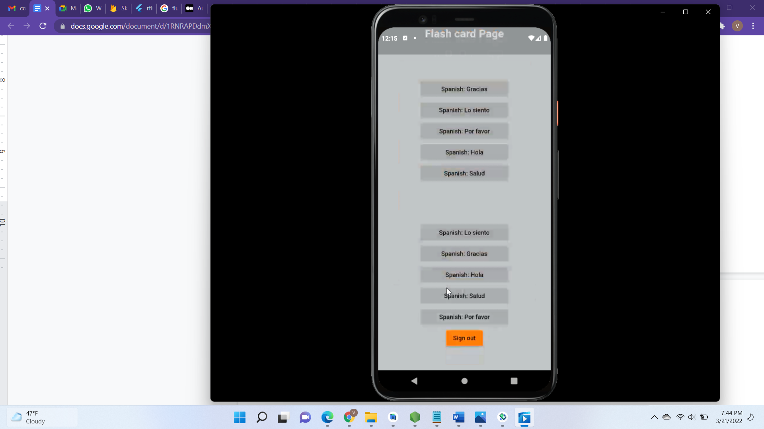

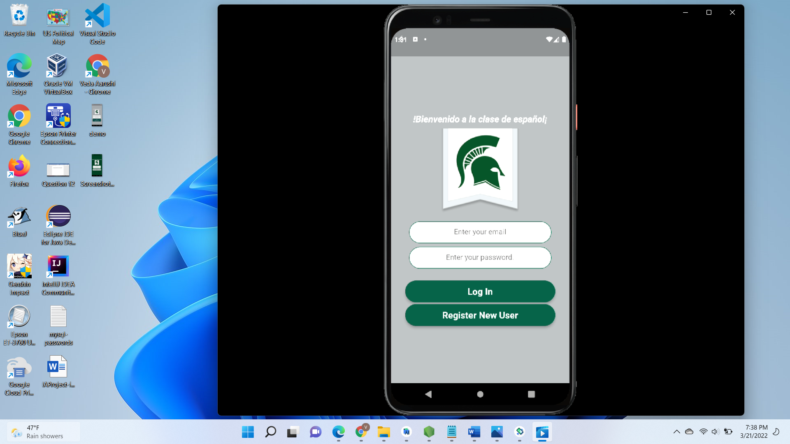

Initial teacher’s view page: Initial teacher’s view navigation: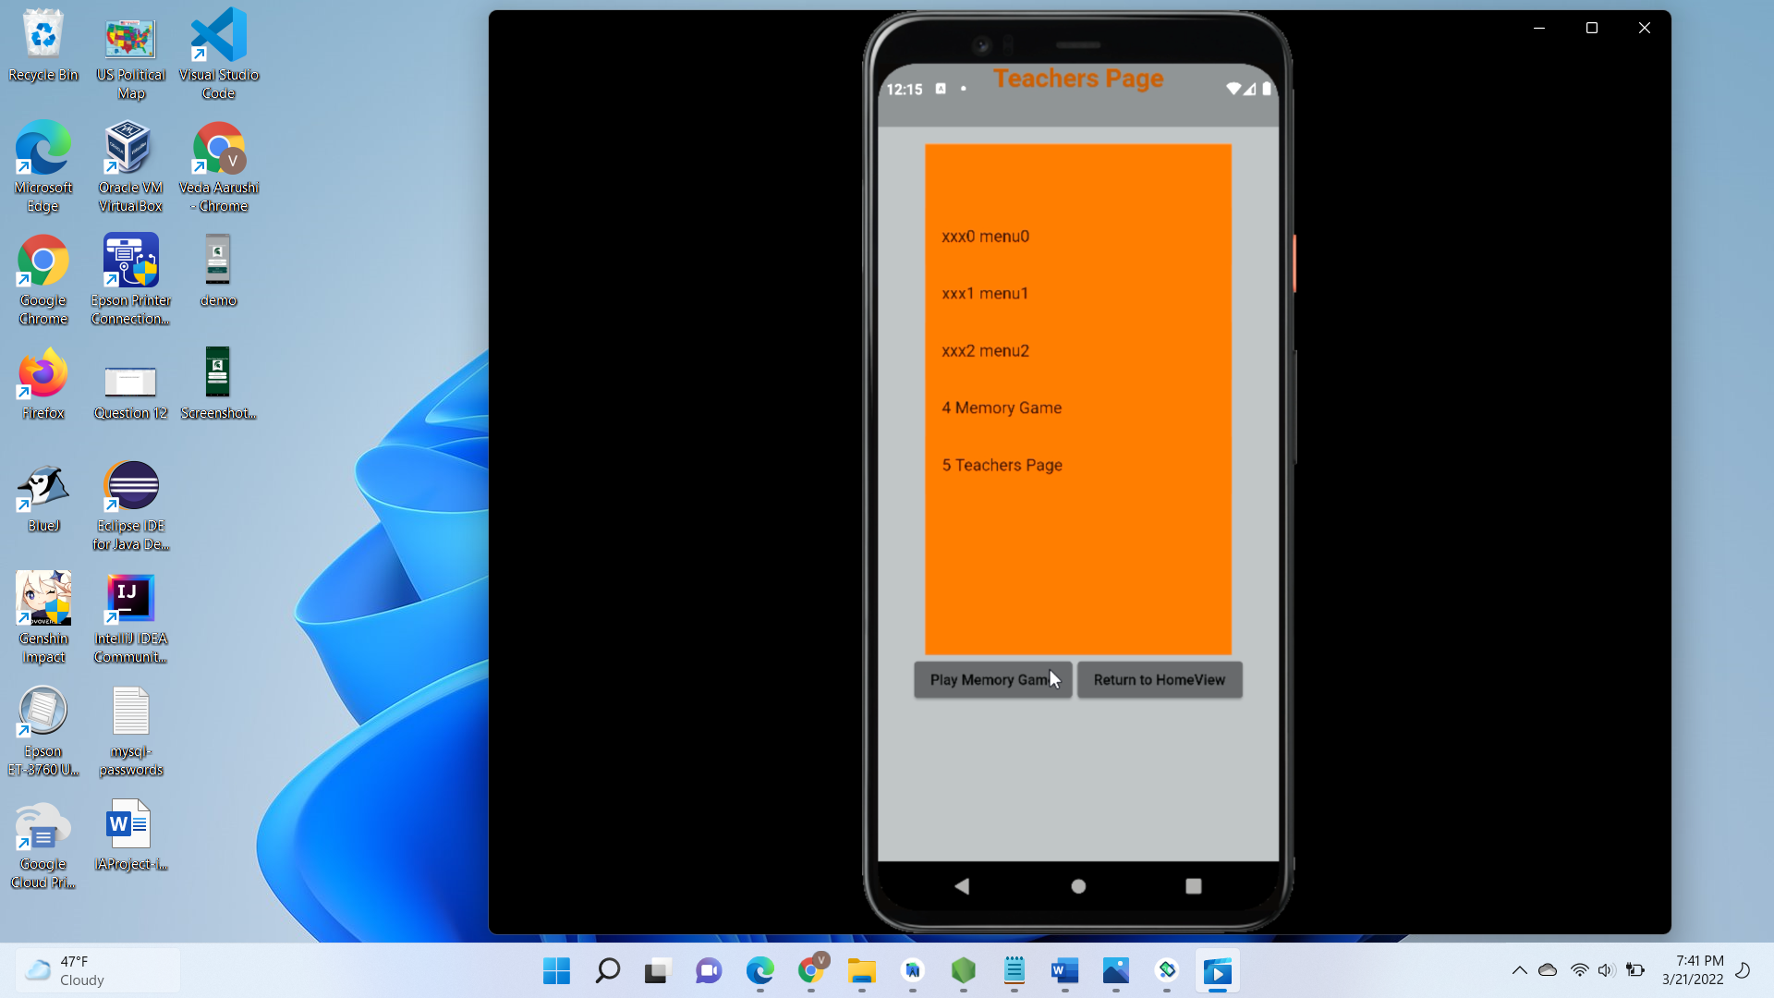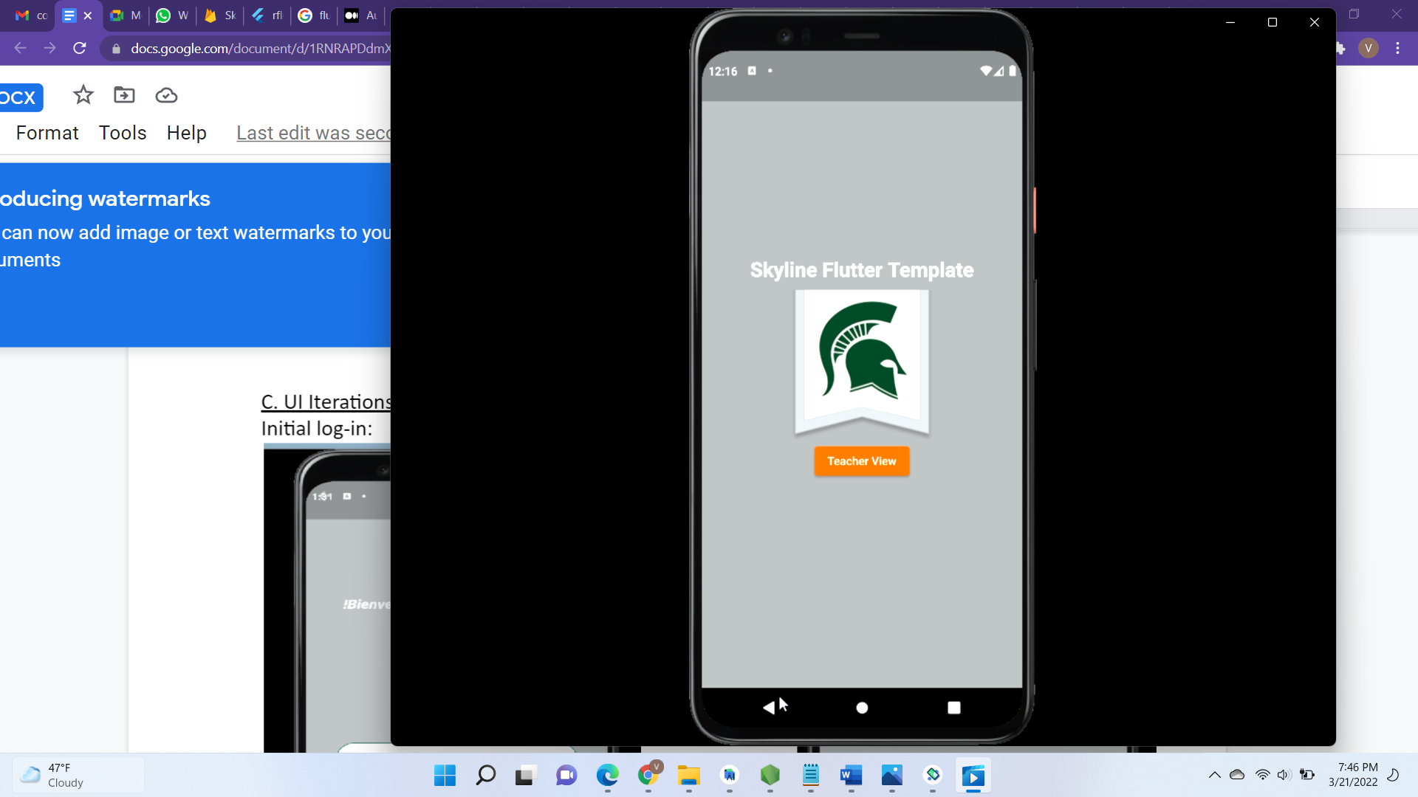

Current View:

Log in: Current registration page: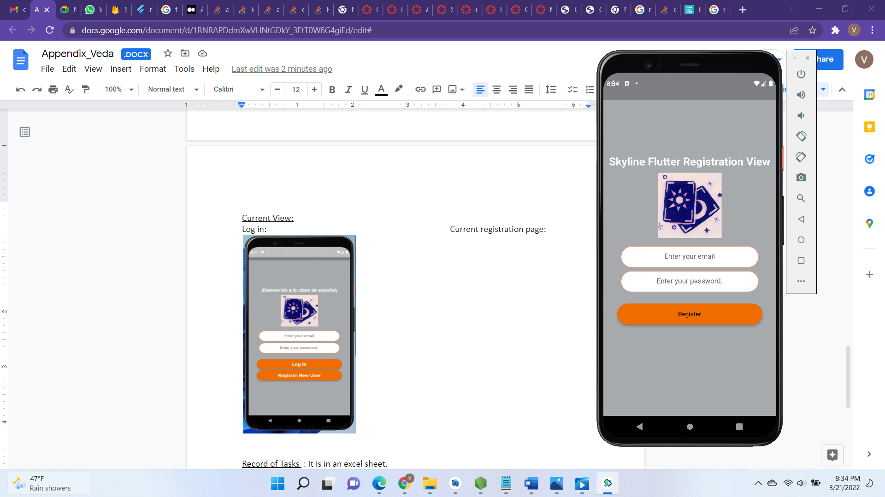

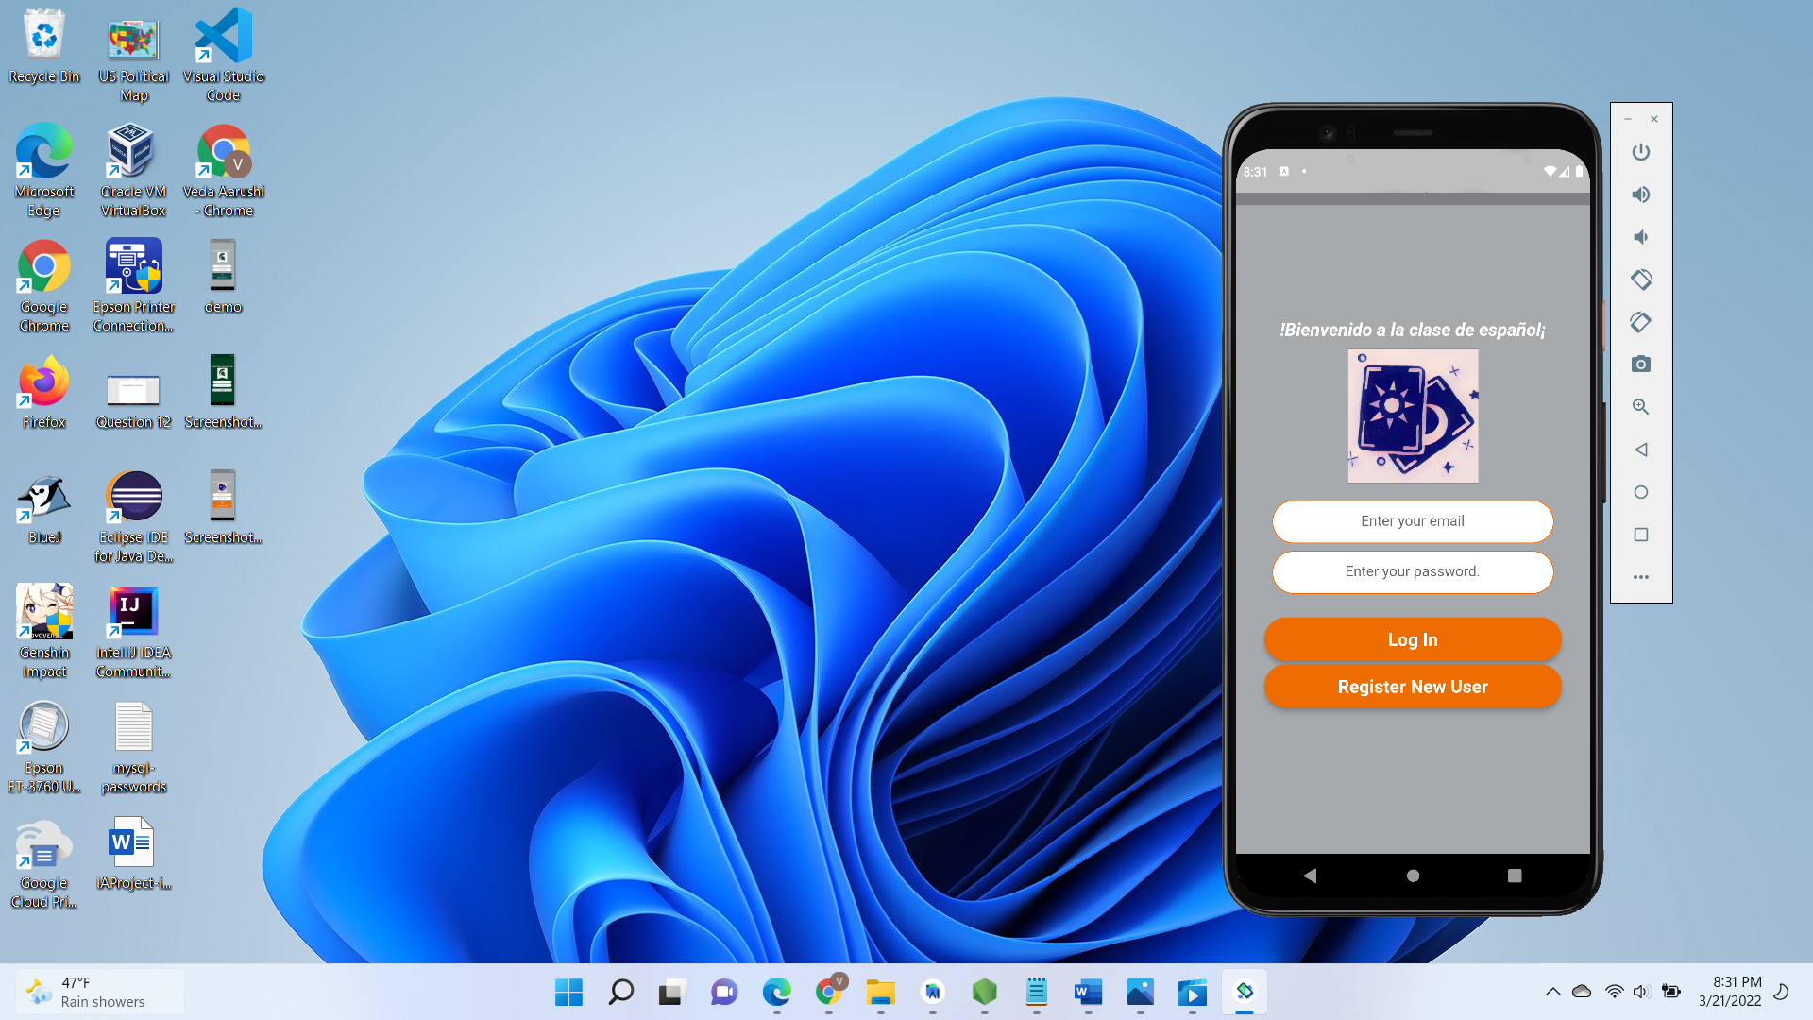

Game menu: Memory game menu: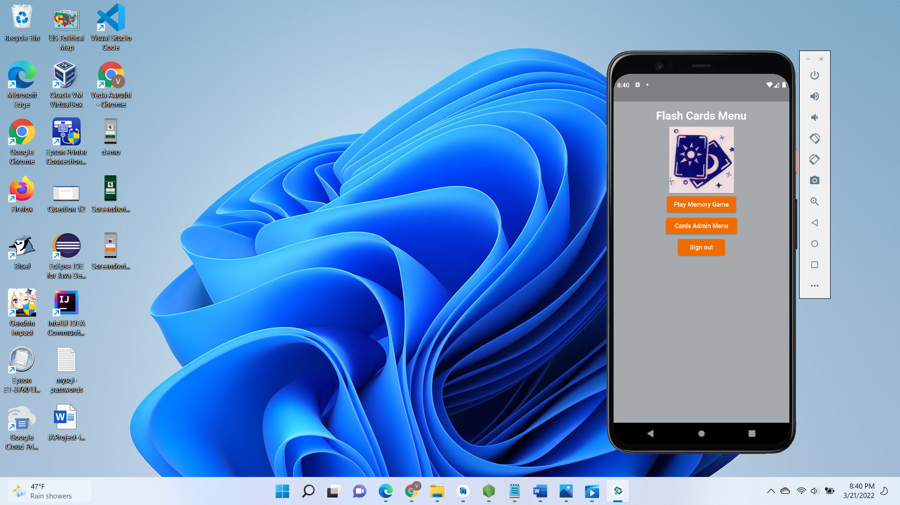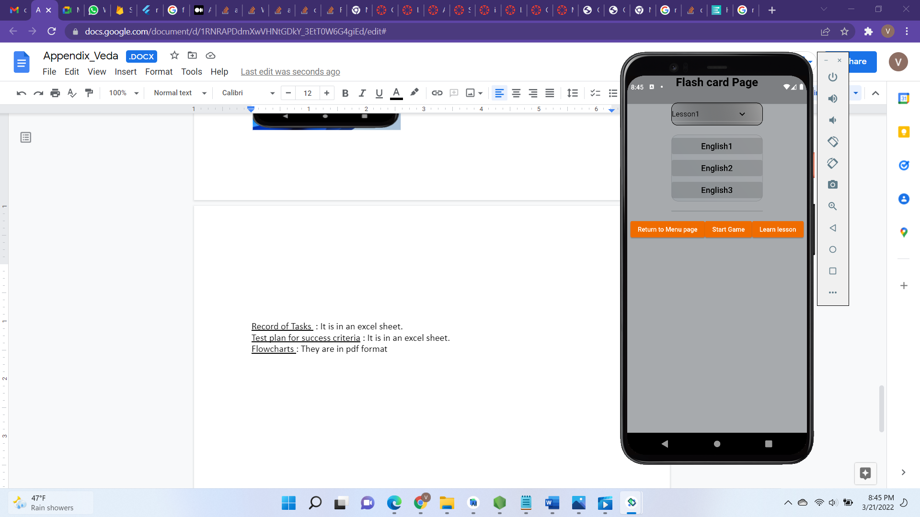

Memory game view:

Memory game view : Cards Admin page:

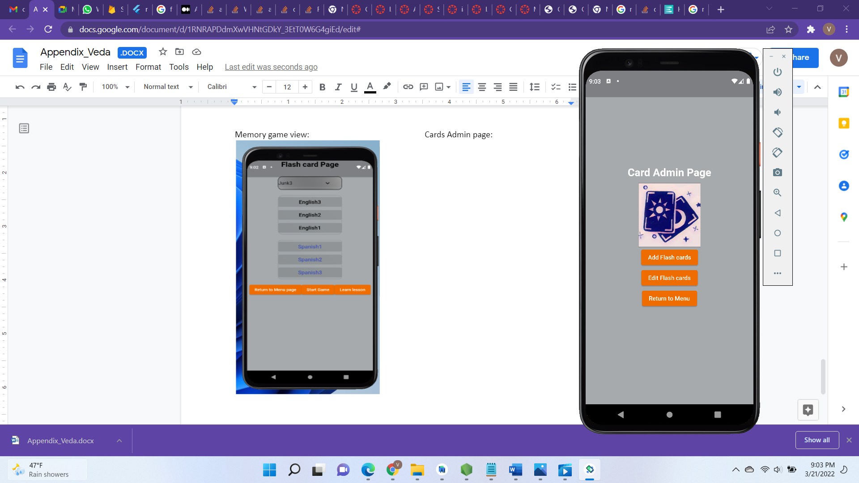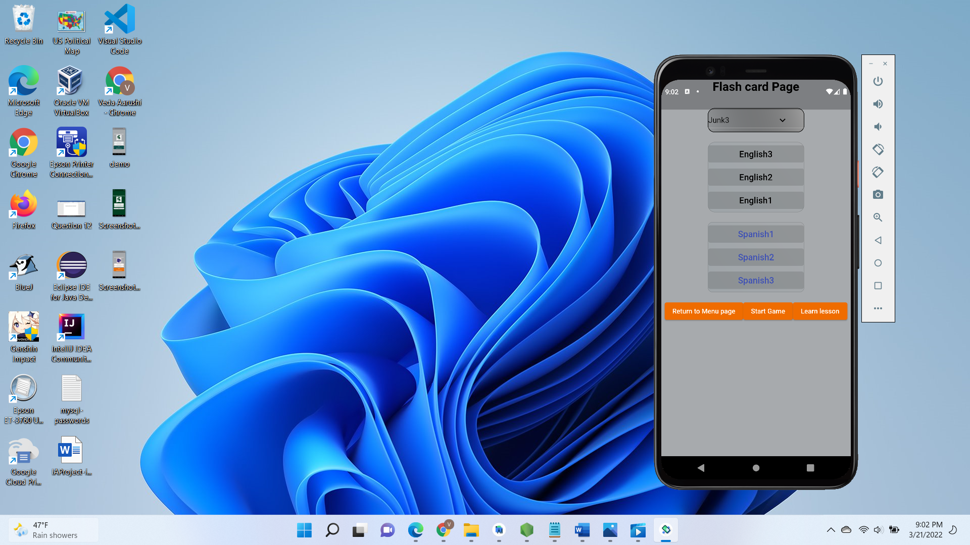

Add Flashcard view: Edit flashcard view: 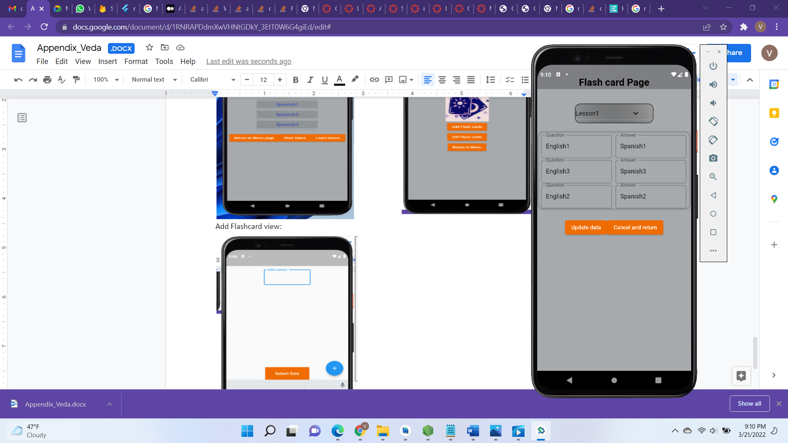

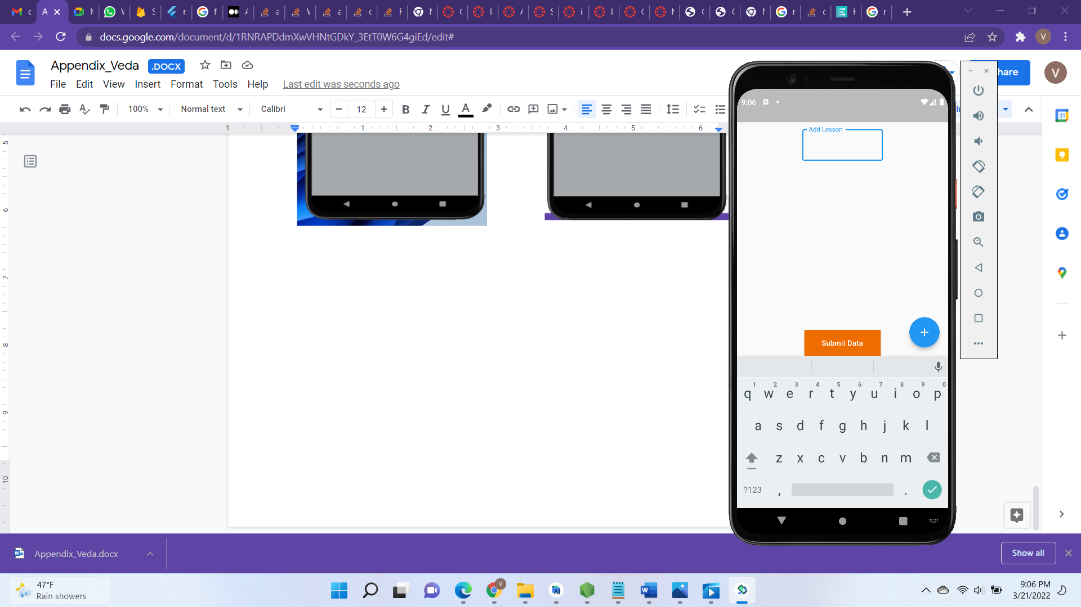

My database:

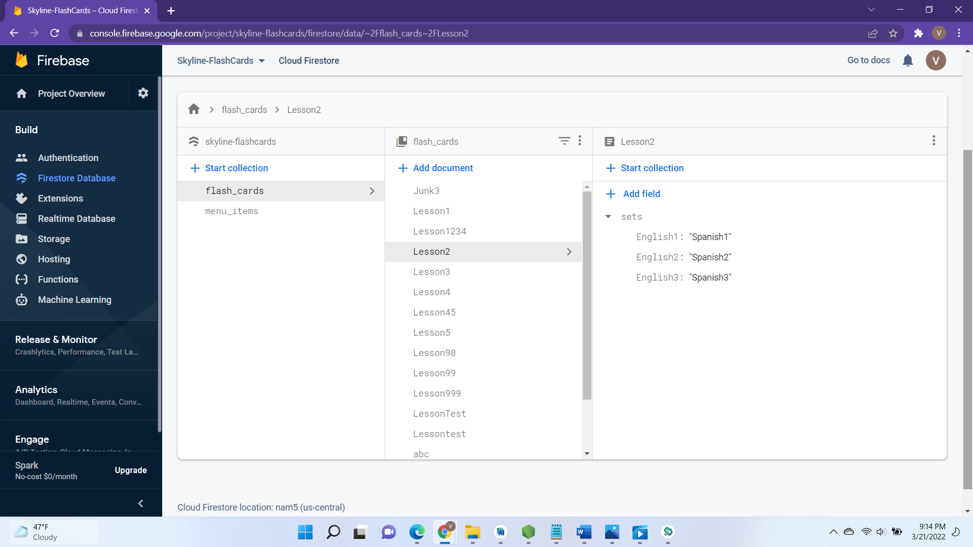

Citations:

[flutter - Can i store a Map<String, Object> inside a Shared Preferences in dart? - Stack Overflow](https://stackoverflow.com/questions/48116773/can-i-store-a-mapstring-object-inside-a-shared-preferences-in-dart)

[Write and Read nested Map to Firebase Document from Flutter - Stack Overflow](https://stackoverflow.com/questions/62123253/write-and-read-nested-map-to-firebase-document-from-flutter)

[How to generate multiple Dropdown dynamically in Flutter? - Stack Overflow](https://stackoverflow.com/questions/63185974/how-to-generate-multiple-dropdown-dynamically-in-flutter)

[Supported data types  |  Firebase Documentation (google.com)](https://firebase.google.com/docs/firestore/manage-data/data-types)

[SetOptions not working in Firestore Flutter WEB - Stack Overflow](https://stackoverflow.com/questions/59344201/setoptions-not-working-in-firestore-flutter-web)

pub.dev. For example: - Flip_card.dart , flutter_dropdown.dart etc.

[android - Keyboard is pushing the FloatingActionButton upward in flutter app - Stack Overflow](https://stackoverflow.com/questions/54115269/keyboard-is-pushing-the-floatingactionbutton-upward-in-flutter-app)